Distinct campaigns:

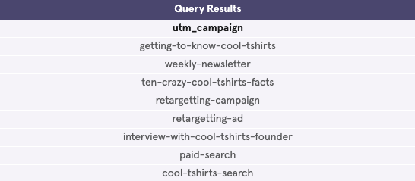

Distinct source:

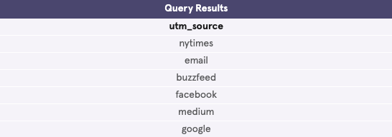

Relation:

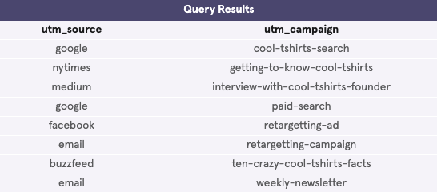

Pages:

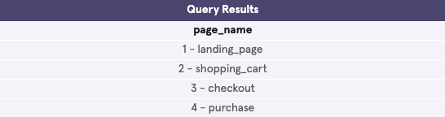

How many first touches per campaign:

WITH first_touch AS (

SELECT user_id,

MIN(timestamp) as first_touch_at

FROM page_visits

GROUP BY user_id)

SELECT pv.utm_source,

pv.utm_campaign,

COUNT(*)

FROM first_touch ft

JOIN page_visits pv

ON ft.user_id = pv.user_id

AND ft.first_touch_at = pv.timestamp

GROUP BY 2

ORDER BY 3 DESC;

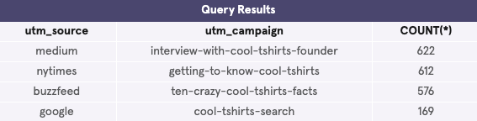

How many last touches per campaign:

WITH last_touch AS (

SELECT user_id,

MAX(timestamp) as last_touch_at

FROM page_visits

GROUP BY user_id)

SELECT pv.utm_source,

pv.utm_campaign,

COUNT(*)

FROM last_touch lt

JOIN page_visits pv

ON lt.user_id = pv.user_id

AND lt.last_touch_at = pv.timestamp

GROUP BY 2

ORDER BY 3 DESC;

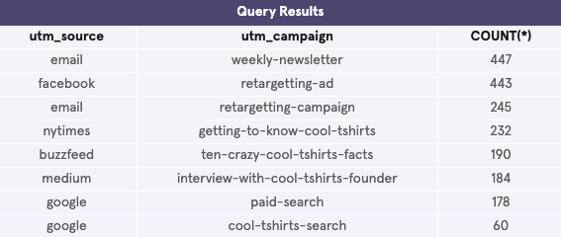

How many visitors make a purchase:

SELECT COUNT(DISTINCT user_id) AS 'purchase_made'

FROM page_visits

WHERE page_name = '4 - purchase';

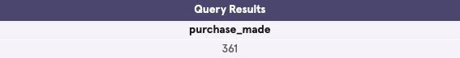

page_visits funnel:

SELECT page_name,

COUNT(DISTINCT user_id) AS 'purchase_made'

FROM page_visits

GROUP BY page_name;

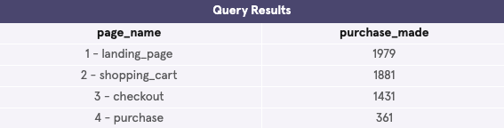

Last touches on purchase page by campaign:

WITH last_touch AS (

SELECT user_id,

MAX(timestamp) as last_touch_at

FROM page_visits

WHERE page_name = '4 - purchase'

GROUP BY user_id)

SELECT pv.utm_source,

pv.utm_campaign,

COUNT(*)

FROM last_touch lt

JOIN page_visits pv

ON lt.user_id = pv.user_id

AND lt.last_touch_at = pv.timestamp

GROUP BY 2

ORDER BY 3 DESC;

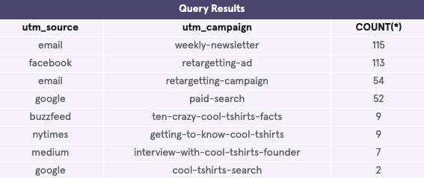

I would say reinvest in:

* interview-with-cool-tshirts-founder
* getting-to-know-cool-tshirts
* ten-crazy-cool-tshirts-facts

Because they bring lots of initial traffic.

Then:

* weekly-newsletter
* retargetting-ad

because they bring lots of last-touches on the purchase page.